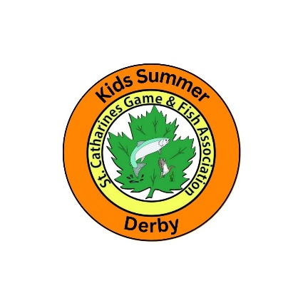
St. Catharines Game & Fish Assoc.
Kids Summer Derby
Wednesday, July 1, 2026 to Saturday, September 5, 2026

How to Enter:
You will find the official Kids Summer Derby button and the required angler information form on the final page of this derby package.
Fish are entered by submitting an email with a photo of the angler wearing or holding the official Kids Summer Derby 2026 button and the fish they caught.
Fill out the required angler information form. Copy and paste or type the information into the email body, attach the picture and email to kidsday.scgf@outlook.com
The picture you are entering must contain the angler with the Kids Summer Derby 2026 button from your derby package to be an eligible entry. We suggest you print the official derby button and pin it to your child’s shirt when out fishing.
You can also save the official button on your phone. Have the angler hold their fish entry and the phone with the button in clear view on the screen.
The fish in the entry picture needs to be clear for the Kids Summer Derby judges to be able to identify the species. We recommend taking several pictures as we know fish do not always cooperate during a photo shoot. A side view of the fish with head, fins and tail is ideal.
The button cannot be digitally added to pictures after the picture is taken.
Entries are accepted by email only at kidsday.scgf@outlook.com

Prizes: Overall Grand Prize: The Dagmar Miller Overall Derby Prize and Trophy. The overall grand prize is awarded to the angler with the most fish species entered from all age groups.
Age 2-6 Prizes and Trophies: The top three anglers with the most species entered will win a prize and a trophy. Seven additional anglers who enter at least two fish species will be entered into a random draw for prizes and medallions. Bonus, receive an additional entry for every three fish species entered after the initial 2
Age 7-11 Prizes and Trophies: The top three anglers with the most species entered will win a prize and a trophy. Seven additional anglers who enter at least three fish species will be entered into a random draw for prizes and medallions. Bonus, receive an additional entry for every three fish species entered after the initial 3
Age 12-16 Prizes and Trophies: The top three anglers with the most species entered will win a prize and a trophy. Seven additional anglers who enter at least four fish species will be entered into a random draw for prizes and medallions. Bonus, receive an additional entry for every three fish species entered after the initial 4
John Gadzo “Gadabout” Biggest Catch Trophy and Prize: Write a story about your biggest catch, the one that got away, an outdoor adventure you experienced or use your imagination to create a fishing fictional story to be entered for prizes. Email us at kidsday.scgf@outlook.com with your entry. The overall story chosen by our judges from all age groups will win the Gadabout grand prize and trophy. For each of the 3 age groups, a story will be chosen by our judges and win a main prize within that group. For each of the 3 age groups, three additional prizes per group will will be selected at random from entries within that group.
Joe Montgomery Fish Art Trophy and Prize: Create an original drawing of a fish species found in Ontario and enter for prizes. Email us at kidsday.scgf@outlook.com with your entry. The overall artwork chosen by our judges from all age groups will win the Joe Montgomery grand prize and trophy. For each of the 3 age groups, an artwork piece will be chosen by our judges to win a main prize within that group. For each of the 3 age groups, three additional prizes per group will be selected at random from the entries within that group.
Weekly prizes: 5 draw prizes will be chosen randomly each week from that week’s entries for all 9 weeks of the derby. The first week will run July 1 to July 11. Weekly winners will be announced Sundays beginning July 12/26 on our Kids Summer Derby Facebook and Instagram pages. All winners will also be notified by email.
Kids Day will be Saturday, September 12/26 at SCGFA located at 61 Lighthouse Rd. in St. Catharines. All kids can compete in the in-person fishing derby from shore on Sept. 12th for additional prizes.
Prizes for the Kids Summer Derby and Kids Day Derby will be presented on Saturday, September 12/26 during the awards/prize ceremony.
All kids and their families are invited to come out and enjoy Kids Day September 12/26. Fishing in the summer derby is not mandatory to participate in Kids Day.
Kids Summer Derby and Kids Day events are free for kids and their families.
Follow us on Kids Summer Derby on Facebook and Instagram for all the latest derby updates and announcements.

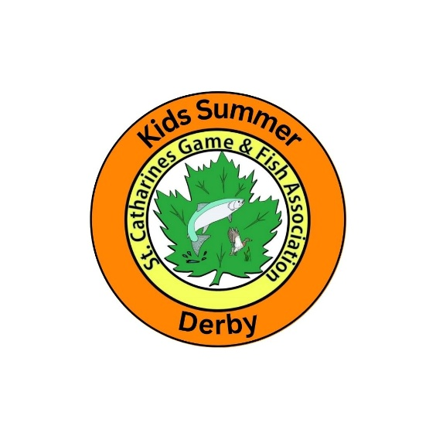

St. Catharines Game & Fish Assoc.
Kids Summer Derby
Wednesday, July 1, 2026 to Saturday, September 5, 2026

RULES AND REGULATIONS

- Kids Summer Derby 2026 is open to all children 2 to 16 years of age inclusive as of July 1/26
- The derby is free for all kids to participate in.
- Kids Summer Derby 2026 will begin Wednesday July 1, 2026 at 6am and finish Saturday, September 5, 2026 at 6pm.
- Make sure to submit your entries by the deadline, as late submissions will not be accepted.
- All entries must include the official 2026 Kids Summer Derby button in your picture to qualify as an entry.
- Digitally enhanced photos including digitally adding the button to the picture will be disqualified.
- Images created by AI will not be accepted.
- It is a condition of entry that the entrant’s parent/guardian submit their child’s email entries.
- It is a condition of entry that the entrant's parent or guardian agrees to release the organizers, sponsors, and Derby Committee from any claims for damages or liability of any nature whatsoever.
- Participants agree to abide by all the regulations of the Ontario Ministry of Natural Resources under the Fish and Game Act.
- Participants agree to abide by fishing regulations in the municipality in which you are fishing.
- We encourage all anglers to wear life jackets and fish with adult supervision.
- Prizes will be awarded based on meeting the derby requirements for each age group. In the event of a tie, the prize will go to the earliest registered email entry timestamp.
- No minimum fish size to enter.
- Any native Ontario species of fish can be entered which are caught in any Ontario waterways. The fish must be caught legally within the Ontario Ministry of Natural Resources guidelines.
- We will accept one hybrid species entry per angler.
- Entries for Koi will not be accepted.

- Crayfish are freshwater crustaceans and do not qualify as a fish species.
- Each fish species will be entered once. Additional fish of the same species will not count as entries.
- Fish must be caught by rod and reel only. No net fishing or gaffing. Snagged or foul hooked fish will be disqualified. All fish must be hooked by their mouth. We encourage live release.
- Gobies are not to be released as per the fishing regulations on invasive species.
- Adults may not fish in the derby. Children 2-16 years may fish with minimal help from adults.
- Age categories are 2-6, 7-10 and 11-16. Age at the time of the start of the derby is used.
- All award prizes as well as any randomly drawn derby prizes will be announced on or before September 9, 2026.
- All derby prizes must be picked up at the St. Catharines Game & Fish Clubhouse Sept. 12, 2026, during the prize awards presentation.
- Derby prizes will not be shipped or mailed.
- All prizes must be accepted as awarded. The derby committee's ruling of prize winners will be final.
- Contestants may enter as many different fish species as they wish; however, each contestant may only win one prize in their category or the overall prize. The Dagmar Miller Memorial overall prize winner will win that prize and all the other prize winners in that age category will move up a place.
- The organizers reserve the right to amend, add to, remove, or otherwise change any of the rules and regulations without prior notice if they deem it to be in the best interest of all parties in the derby.
- Unclaimed prizes become the property of the SCGFA Kids Summer Derby.
- By entering your child’s email entry, you are agreeing that your child's name and picture may be published online as it relates to participation or results of the Kids Summer Derby.
- By entering your child's email entry, you are also consenting to your child participating in the Kids Summer Derby and you are acknowledging you have read and understood the Kids Summer Derby rules and regulations.

Good Luck and Good Fishing

The following information is to be included in your email submission:
Angler’s Full Name:
Angler’s Age:
Species of fish:
City/town/waterway where the fish was caught:
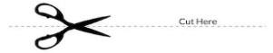
**By submitting an entry, you agree as the child’s parent/guardian that your child’s name and picture may be published online as it relates to participation or results of the Kids Day Derby.

Kids Summer Derby Official Button
